**Research on Image Process (Corn)**

**Contents**

**S.No Chapters**

1. **Introduction**
2. **Technology Prerequisites**
3. **History of Image Processing**
4. **Data Sets**
5. **Summary**

**CHAPTER-1: INTRODUCTION**

The corn plant is one of the most widespread edible grain crops in the world, as it is used as food for humans, fodder for livestock, a source of biofuels, and a raw material in the manufacture of various products. Approximately 10,000 years ago, they chose plant seeds that are characterized by easy grinding, good taste, rapid growth, and better production, which produced a crop with a greater number and size of corn kernels, and the development process of corn continued until it reached its familiar form today.

Corn is an important crop in agriculture. A major problem in food crops all over the world. Awaited, natural disease control. The key to success in diseases is rapid diagnosis of diseases, pesticides can be packed in time.

It is a plant of high value and is called corn or sweet corn. It ranks first in terms of grain production, ranks third. The source of energy in human food.

This work presents plant disease detection using an image processing technique for an automated vision system used in the agricultural field.

It is very difficult for a farmer to identified various disease in plants. The estimated annual crop losses due to plant disease at the worldwide is $60 Billions. The traditional tools and techniques are not very useful since it takes lots of time and manual work

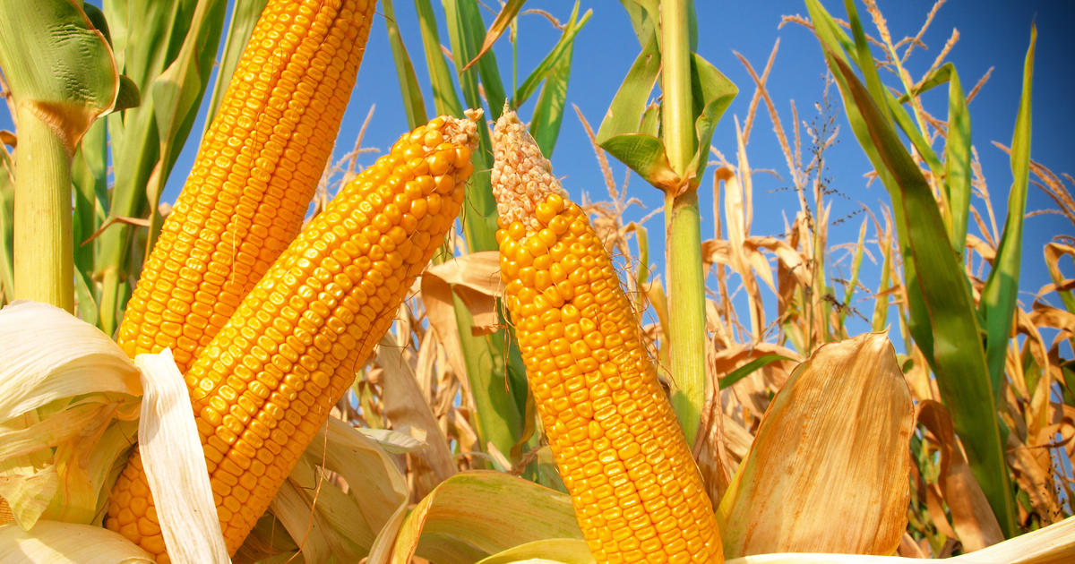

**1.1 FOOD**

Food is one of the basic needs of human life. The demand for food is increasing due to an exponential increase in the world's population. To overcome such a massive demand for food, agricultural practitioners suggested the use of different insecticides and pesticides to increase the yield of the crops.

The use of these insecticides and pesticides increases the yield of plants, but using these in large amounts can degrade the quality of the soil, which makes crops more prone to different diseases. These diseases can negatively affect the crop yield and reduce the profit of the farmers.

If the farmers can sense the plant diseases in the initial stages, it is possible to take necessary actions to remedy the situation.

Detecting length, width, quality and also disease in a large field of crops with naked eyes is a challenging task. Thus, to simplify this process, there is a need for a system for automatic detection of plant crop.

Due to the number of food and industrial products that dependent on it, corn is widely regarded as one of the world’s most vital crops. Not only is corn used to create products such as starch, flour, and ethanol, it is also the primary feed for livestock (pigs, cows, cattle, etc.) due to being rich in nutrients and proteins. In 2019, corn was the United States’ (U.S.) largest grown crop accounting for more than 90 million acres of land and adding more than $140 billion to the U.S. economy. By 2050, the world’s population is expected to reach 9.1 billion. With the world’s population increasing and the amount of arable land non-increasing, changes must occur to maximize corn yield while maintaining the same (or fewer) input parameters.

**CHAPTER-2: TECHNOLOGY PREREQUSITES**

**2.1 Technology**

Previous studies proposed deep learning based methods to accurately predict corn yield based on factors such as genotype, weather, soil, and satellite imagery, but none of these studies are considered as the High Through-put Image on commercial corn.

**2.2 Deep Learning**

Deep learning is a subset of machine learning and AI, and is essentially a neural network with three or more layers. These neural networks aim to mimic the activity of the human brain; however, they fall far short of the human brain’s ability to learn from large amounts of data.

While a single-layer neural network can provide approximate predictions, additional hidden layers can aid in optimizing and refining the accuracy. Machine learning is a subfield of AI that allows the system to learn from concepts and knowledge without being explicitly programmed.

Deep learning is built on a combination of **machine learning algorithms** that use multiple nonlinear transformations to model high-level abstractions in data.

**Recurrent neural network** (RNN) and **convolutional neural network** (CNN) are two standard deep learning networks used in agriculture.

**2.3 Convolutional Neural Network (CNN)**

A CNN is a deep learning algorithm composed of multiple convolutional layers, pooling layers, and fully connected layers.

It is a multi-layer neural network based on the animal visual cortex. CNNs are mainly used for **image processing** and handwritten character recognition.

CNNs have been used for image classification, object detection, fragmentation of images, voice recognition, text and video processing, and medical image analysis, among other functions.

A CNN architecture typically consists of convolutional, pooling, and fully connected layers.

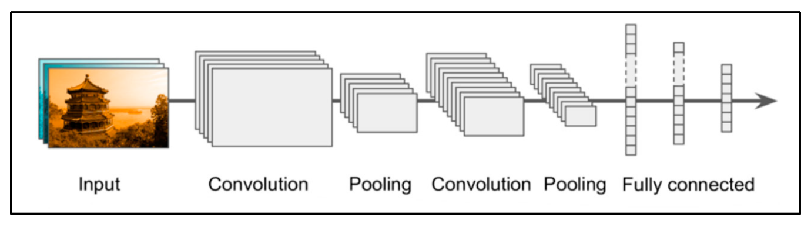

Figure 1. CNN architecture.

**2.4 Recurrent Neural Network (RNN)**

An RNN is a neural sequence model that performs exceptionally well on crucial tasks such as language modelling, speech recognition, and machine translation.

RNNs, as opposed to traditional neural networks, take advantage of the network’s sequential information; this attribute is critical in many applications where the structure inherent in the data sequence contains valuable information.

**2.5 Applications of Deep Learning in Agriculture**

Deep learning algorithms are being used in smart agriculture to monitor various related parameters and observe them from anywhere in the world. We have found in recent surveys that mainly they studied the benefit of deep learning in any one of the agricultural applications.

In this survey, we have given an overview of the contributions of deep learning in the different known applications of smart agriculture.

We tried to analyse which deep learning model is suitable for which applications and which one is more efficient and effective, among others.

We have noticed that researchers’ interest is increasing in using the CNN algorithm in plant disease detection and classification applications, and it has given tremendous results.

**2.6 Identification/Classification of Plant Disease**

Disease fungus, microbes, and bacteria obtain energy from the plants on which they dwell, affecting crop productivity. If not diagnosed in time, this can cause significant economic losses for farmers. Pesticides used to remove pathogens and restore crop functionality impose substantial financial pressures on farmers. Excessive pesticide usage also results in environmental degradation and affects agricultural areas’ water and soil cycle.

Another CNN technique to detect, classify and identify plant disease. It has proved output result accuracy ranging from **91 to 98 %** and an average performance of **96.3%** for thirteen different plant diseases. It can also differentiate between healthy and unhealthy leaves and distinguish them from their backgrounds. They used a CNN model in agriculture to recognize and classify plant images and achieved the highest accuracy of **99.58 %**. They employed off-the-shelf ConvNet representations to evaluate the plant growth of a maize crop.

**2.7 Corn Counting**

The difficulty of identifying and counting the corn kernels on each tree is crucial in crop yield estimation in agriculture. Manual counting is time-consuming and labor-intensive.

The automated crop counting approach can help project yields and organize harvesting plans to increase productivity and profit margin.

A simulated model of a deep convolutional neural network **(CNN)** for yield estimation is developed and tested to know the exact number of fruits. It used a modified version of Inception-ResNet architecture, and experimental results showed an average test accuracy of **91%**.

**CHAPTER-3: History of Image Processing**

Image processing techniques have also been utilized to analyze and count corn kernels, particularly for yield estimation and quality assessment. Here's an overview of the history of image processing in corn kernels and how kernel counting is typically performed.

**3.1 Computer Vision and Machine Learning (1990s-Present):**

The integration of computer vision and machine learning techniques revolutionized image processing. Algorithms such as neural networks, support vector machines, and deep learning architectures enabled more advanced tasks like object detection, image classification, and image synthesis. These techniques have found applications in various domains, including autonomous vehicles, robotics, and facial recognition.

**3.2 Real-Time Processing and Mobile Applications (2000s-Present):**

The widespread availability of powerful computing devices, such as smartphones, led to the demand for real-time image processing. Algorithms were optimized for speed and efficiency to enable on-device image analysis. Mobile applications for image recognition, augmented reality, and computational photography became increasingly popular.

**3.3 Early Approaches:**

In the early stages, manual methods were predominantly used to count corn kernels. Researchers would manually separate and count the kernels, which was a time-consuming and labor-intensive process. These methods were not suitable for large-scale analysis.

**3.4 Image Acquisition:**

With the development of digital imaging technology, researchers began capturing high-resolution images of corn cobs. This involved using cameras, scanners, or specialized imaging equipment to acquire images of corn ears or individual kernels. The images were usually captured under controlled lighting conditions to ensure consistent results.

**3.5 Image Preprocessing:**

Image preprocessing techniques were applied to enhance the acquired images and improve the accuracy of subsequent analysis. Preprocessing steps might include noise reduction, contrast adjustment, and image normalization to standardize the appearance of the kernels.

**3.6 Segmentation:**

The next step involved segmenting or separating the individual kernels from the rest of the image. Various image segmentation algorithms were employed to isolate the kernels based on their color, shape, texture, or intensity variations. These algorithms aimed to accurately detect the boundaries of each kernel.

**3.7 Feature Extraction:**

Once the kernels were segmented, feature extraction techniques were applied to capture relevant information about the kernels. Features such as size, shape, color, and texture were extracted from each individual kernel. These features provided valuable information for further analysis and counting.

**3.8 Kernel Counting:**

The actual counting of [kernels](https://www.frontiersin.org/articles/10.3389/frobt.2021.627009/full) was performed using different approaches, depending on the level of automation desired. Here are a few commonly used methods:

**3.8.1 Manual Counting:**

In some cases, the segmented kernels were manually counted by human operators. However, this method was prone to human error and was not suitable for large-scale analysis.

**3.8.2 Template Matching:**

Template matching involved creating a reference template of a single kernel and then comparing it to the segmented kernels in the image. Similarity measures were used to identify and count kernels that closely matched the template.

**3.9 Machine Learning:**

Machine learning algorithms, such as convolutional neural networks (CNNs), have been increasingly employed for kernel counting. These algorithms were trained on large datasets of labeled images, where the ground truth kernel count was provided. The CNNs learned to detect and count kernels automatically based on the patterns and features observed in the training data.

**3.10 Advancements:**

Recent advancements in computer vision and machine learning techniques have led to more accurate and efficient kernel counting. Deep learning approaches, such as object detection and instance segmentation, have been applied to handle complex scenarios where kernels might be occluded or overlapping.

**3.11 Methodology:**

The goal of this study is to localize and count corn kernels in a corn ear image taken in uncontrolled lighting conditions. To solve this problem, we first detect all kernels in a corn ear image and then estimate the total number of kernels by counting the number of detected kernels. As a result, the underlying research problem is a single class object detection problem. As shown in the below figure, the number of objects (kernels) in a corn ear is extensive (up to 800 kernels) and the objects are in close proximity to one another, making the problem more challenging.

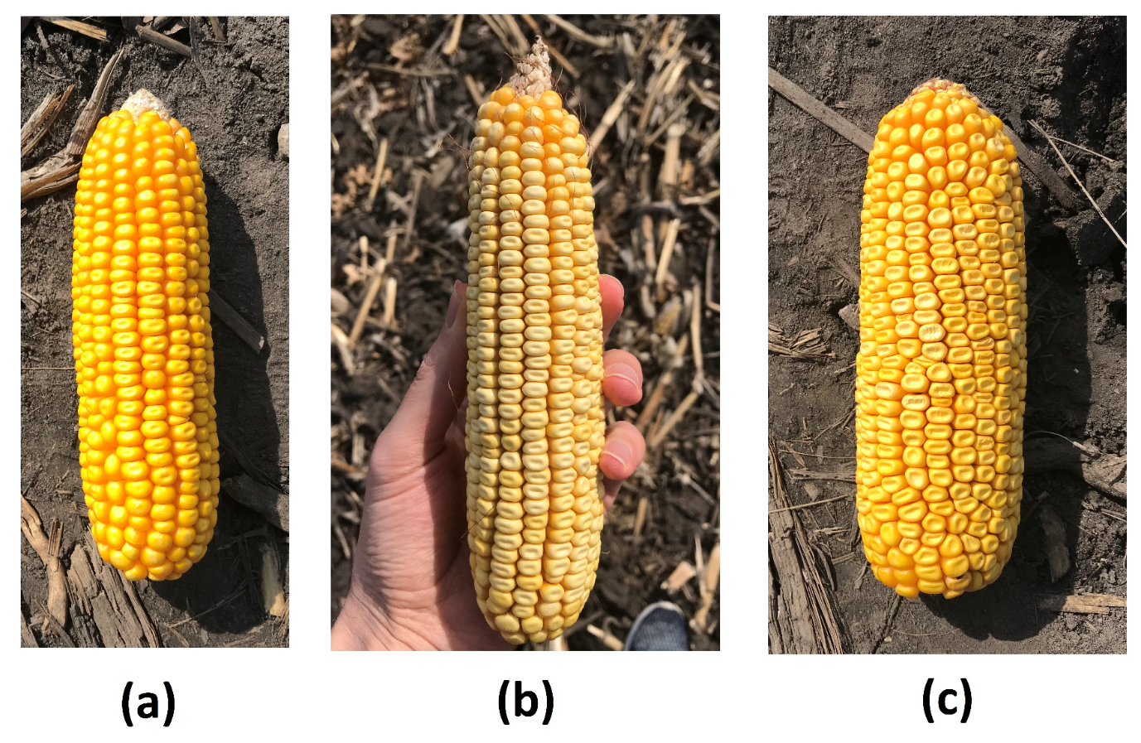

**Figure**: Three genetically different corn ears. Images (a–c) have different backgrounds. We included different types of backgrounds such as soil, grass, and hands in the training data to make the proposed method robust against the image background.

We use a sliding window approach for kernel detection in this study. At each window position, a convolutional neural network classifier returns a confidence value representing its certainty that the current window contains a kernel or not.

After computing all confidence values, a NMS is applied to remove redundant and overlapping detections. Finally, windows that are classified as a kernel are passed to a **regression model**.

The regression model takes in a set of kernel-classified windows which are image patches chosen by the kernel classifier model. Then, each of these selected image patches is fed to the regression model.

For example, all kernel-classified windows are shown with blue bounding boxes in Figure 2.

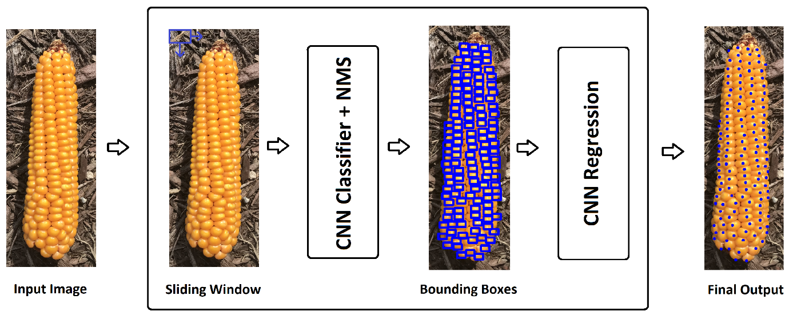

Figure2. Modeling structure of our proposed corn kernel detection method.

**3.12 Corn Kernel Classifier**

In this paper, we apply a sliding window approach for kernel detection problem which requires a supervised learning model to classify the current window as either kernel or non-kernel. We use a CNN to classify image patches as CNNs have been shown to be a very powerful method for the image classification tasks.

The CNN model takes in image patches with size of **32×32 pixels**. The CNN architecture for kernel classification is defined in Table 1. All layers are followed by a batch normalization and ReLU nonlinearity except the final fully connected layer which has a sigmoid activation function to produce a confidence value representing the CNN’s certainty that an input image patch contains a kernel or not. Down sampling is performed with average pooling layers.

Table: 1

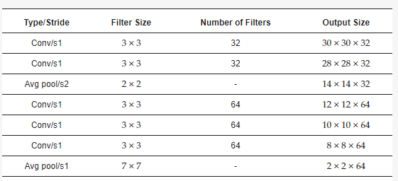

**CHAPTER-4: DATASETS**

**4.1 Dataset:**

The [dataset](https://naagar.github.io/cornseedsdataset/) is highly varied in a number of manners including image size, resolution, number of ears present, total number of kernels present, background, lighting, corn variety, image type (i.e., photograph vs. cartoon), amount of zoom, etc. This is in stark contrast to the datasets used for many corn kernel counting applications which are restricted to the domain expected at inference: an outdoor image of a single ear of corn, belonging to a single (or limited set) corn variety, vertically oriented, at a roughly standardized size, at a standardized resolution, and with minimal shadowing or occlusions. Limiting the training domain in this manner can suffice if the domain at inference time is guaranteed to be similar; however, these models will likely not generalize well and may be unstable to unanticipated shifts in the inference domain. Instead, we elect to train the model on a broad set of data and then allow for fine-tunning to specific, narrower application-specific domains if needed.

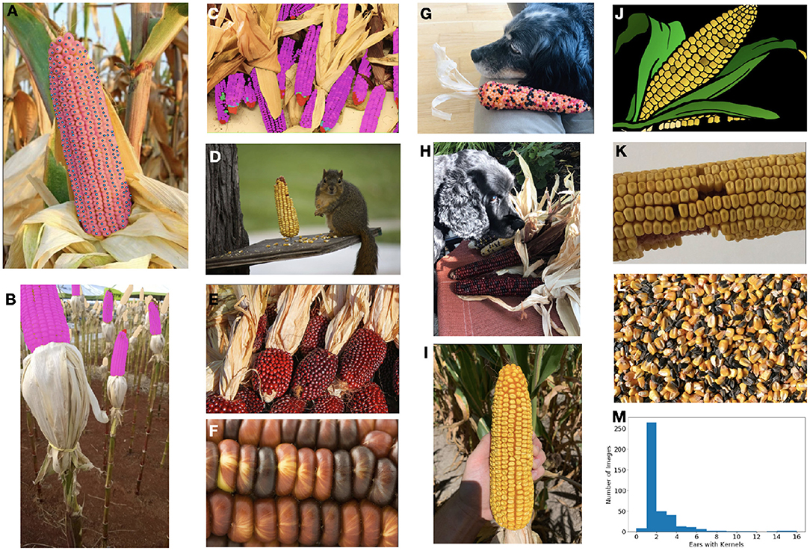

FIGURE. The ultimate goal of this model is count and localize the healthy kernels on ears of corn.